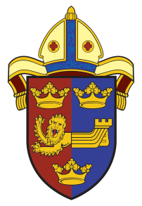

The Blackbourne Team
The
INSTITUTION, INDUCTION, AND INSTALLATION
of

The Revd Dr Karen Burton

as Rector of
The Blackbourne Team Benefice

by
the Bishop of Dunwich
the Rt Revd Dr Mike Harrison

Will take place on
Monday 2nd September 2019 at 7.30pm
In St Marys Church Ixworth

Followed by refreshments in the Village Hall

All are welcome to attend

